**Medicinal Plant *Recognition Using Deep Learning and Real-Time Camera Feed***

**Abstract**

The **Medicinal Plant *Recognition Using Deep Learning and Real-Time Camera Feed*** project is designed to identify plant species through a live webcam feed, offering a real-time, user-friendly solution for automatic plant classification. The system leverages a pre-trained deep learning model, **MobileNetV2**, with transfer learning to classify fourty common plant species: **Aloe Vera**, **Neem**, **Tulsi**, and **Nagfani etc**. The app streams live video, overlays the predicted plant species, and updates dynamically, making it interactive and intuitive. The system uses **Flask** for web deployment, **TensorFlow/Keras** for deep learning predictions, and **OpenCV** to capture and preprocess the webcam feed. The model is fine-tuned with custom dense layers to classify the fourty plant species, using **categorical cross-entropy** as the loss function and the **Adam optimizer** for training. After training, the system achieves a high **validation accuracy of 94%**, demonstrating the effectiveness of the transfer learning approach. The application also features real-time feedback with plant species predictions, displayed alongside class probabilities. This tool has great potential for various applications, including educational tools, gardening assistance, and conservation efforts.

**Introduction**

Plant identification has historically been a labor-intensive process, requiring expertise in botany and significant manual effort to accurately identify species. While this process remains essential for various applications, from agriculture to environmental conservation, it has become increasingly impractical due to the time and resources involved, especially when real-time identification is needed. In recent years, advances in computer vision and machine learning have provided a promising avenue for automating and streamlining the plant identification process.

The project **Medicinal Plant *Recognition Using Deep Learning and Real-Time Camera Feed*** seeks to solve the problem of manual plant species identification by providing a real-time, automated solution that can classify plants using deep learning. The system is designed to work with a live webcam feed, making it easy for users to identify plant species on the spot. The application leverages the power of **transfer learning** using a pre-trained model, **MobileNetV2**, which was fine-tuned with a custom dataset of fourty plant species: **Aloe Vera**, **Neem**, **Tulsi**, and **Nagfani etc**.

**Real-time feedback** is central to the system's design, allowing users to receive immediate predictions as they point their camera at plants. As the webcam streams video, the system processes each frame, makes predictions, and overlays the predicted species name and corresponding probabilities on the screen. This dynamic updating makes the system interactive, providing immediate responses to user actions. Furthermore, the system is designed to be accessible via the web using the **Flask framework**, allowing users to interact with the model easily through a simple, browser-based interface.

The core technology behind this system is deep learning. Specifically, it uses **MobileNetV2**, a lightweight convolutional neural network (CNN) pre-trained on the **ImageNet** dataset. The model serves as the **feature extractor**, and additional custom layers are added to classify the plant species. By using a pre-trained model, the system takes advantage of knowledge learned from a vast and diverse set of images, significantly improving its generalization and accuracy on plant images, even with a limited amount of training data.

Overall, this project demonstrates the potential of **deep learning and computer vision** to transform plant identification, enabling individuals with little to no botanical knowledge to easily identify plant species in real-time, using just a webcam. The application is simple, effective, and highly interactive, with numerous potential uses in education, gardening, and environmental research.

**Objective**

The main objectives of this project are:

1. **Real-Time Plant Identification:**  
   To create a system that uses a live webcam feed to identify plant species in real-time, providing instant feedback to users.
2. **Use of Transfer Learning:**  
   To apply transfer learning with the pre-trained **MobileNetV2** model for efficient plant classification, leveraging the pre-learned features on large datasets and adapting it to the plant species dataset.
3. **Interactive Web Application:**  
   To build an interactive web application that displays real-time plant species predictions and confidence levels as part of a seamless user experience.
4. **Enhancing Generalization and Accuracy:**  
   To use **data augmentation** and a small dataset to improve the generalization capability of the model, ensuring accurate predictions across a wide variety of conditions.

**Significance of the Study**

The significance of this study lies in its ability to bridge the gap between **machine learning** and **environmental education**. By automating plant identification, the system reduces the dependency on expert knowledge, enabling individuals from all walks of life, including hobbyists, students, and farmers, to identify plants quickly and accurately. The integration of **real-time video streaming** ensures that the application is not just a tool for identifying plants in a static setting but can also be used dynamically in various environments, such as gardens, forests, or urban spaces.

This project’s practical significance extends to several fields:

* **Educational Tools:**  
  It can serve as an interactive tool in educational institutions, helping students and environmental enthusiasts to learn about plant species in an engaging manner.
* **Gardening and Agriculture:**  
  Gardeners and farmers can use the tool to identify plants quickly, aiding in plant care and management.
* **Conservation Efforts:**  
  By identifying plant species in real time, conservationists can monitor endangered species and maintain biodiversity.
* **Botanical Research:**  
  The system can be used in research settings to streamline the process of cataloging and studying plant species.

**Methodology**

The methodology for this project follows a systematic process that combines **computer vision**, **deep learning**, and **web technologies**. Below is an outline of the steps involved:

1. **Dataset Collection and Preprocessing:**  
   The dataset used for training the model consists of images of four plant species: **Aloe Vera**, **Neem**, **Tulsi**, and **Nagfani**. These images were collected from various sources and preprocessed for training. The preprocessing steps include resizing images to **224x224 pixels** (the required input size for **MobileNetV2**), **data augmentation** (such as rotations, flips, and zooming), and normalization to scale pixel values.
2. **Transfer Learning with MobileNetV2:**  
   Transfer learning is a key component of the model’s design. **MobileNetV2**, a pre-trained model on **ImageNet**, is used as the **feature extractor**. The model is frozen at the initial layers to preserve the learned features from ImageNet. A custom classification head is added, consisting of dense layers, to predict one of the four plant species based on the extracted features.
   * **Input Layer:** The model receives images resized to **224x224** pixels.
   * **Feature Extraction:** MobileNetV2 extracts high-level features from the input image.
   * **Classification Layer:** A custom dense layer is added for plant species classification.
3. **Training the Model:**  
   The model is trained using the **categorical cross-entropy loss function** and the **Adam optimizer**. The dataset is split into **80% for training** and **20% for validation**. The model is trained for a maximum of 20 epochs, with early stopping implemented to avoid overfitting. The training process also involves monitoring the **validation accuracy** and adjusting the model as needed.
4. **Performance Evaluation:**  
   After training, the model’s performance is evaluated on the validation set. The **validation accuracy** is around **94%**, demonstrating the model’s ability to generalize well on unseen data. The low loss and high accuracy indicate that the model is effectively learning the features that differentiate the plant species.
5. **System Architecture and Web Integration:**  
   The system is built using **Flask** as the backend framework, which serves the web application. The **TensorFlow/Keras** model is deployed on the server, where it is loaded to make predictions.
   * **OpenCV** is used to capture frames from the live webcam feed, preprocess them, and pass them to the trained model for prediction.
   * **Real-time Predictions:** The model’s predictions, along with the corresponding confidence levels, are overlayed on the webcam feed and displayed on the web interface.

**Model**

The model used in this project is based on **MobileNetV2**, which is a **lightweight deep learning model** designed for mobile and edge devices. It is pre-trained on **ImageNet**, a large-scale image classification dataset, which enables the model to extract useful features from images efficiently. The fine-tuning process involves adding a custom classification head that predicts the plant species based on the extracted features.

* **Layers Used:**  
  MobileNetV2's convolutional layers serve as feature extractors, while a custom dense layer is used for classification.
* **Loss Function:**  
  **Categorical Cross-Entropy** is used since the task is a multi-class classification problem.
* **Optimizer:**  
  The **Adam optimizer** is used for training due to its effectiveness in dealing with sparse gradients and adaptive learning rates.

**Process Steps**

1. **Collect Image Data:**  
   Images of the fourty plant species are collected and preprocessed (resized, augmented, normalized).
2. **Train the Model:**  
   MobileNetV2 is used as the feature extractor, and custom dense layers are added to classify the plant species.
3. **Build the Web Application:**  
   The backend is developed using Flask, and the model is integrated with OpenCV to process live webcam feed.
4. **Real-Time Feedback:**  
   The webcam feed is processed to make real-time predictions, and results are displayed with probabilities.

**Requirements**

**Hardware Requirements**

* **Processor**: Intel Core i5 or higher
* **RAM**: 8 GB or more
* **Storage**: 512 GB SSD or higher

**Software Requirements**

* **Operating System**: Windows or macOS
* **Development Environment**: Visual Studio
* **Programming Language**: Python 3.9 or above

## **Technology Used**

### ****1. Python****

Python is a high-level, versatile programming language known for its simplicity, readability, and vast ecosystem of libraries and frameworks. It is widely adopted in domains such as machine learning, web development, data analysis, and automation.

**Key Aspects:**

* **Ease of Learning**: Clean and readable syntax, ideal for beginners.
* **Extensive Libraries**: Rich collection including Pandas, NumPy, TensorFlow, Keras, Flask.
* **Versatility**: Supports a wide range of applications from web development to artificial intelligence.
* **Community Support**: Strong open-source community with active contributions and support.

**Applications in Domains:**

* **Data Analysis & ML**: Pandas, NumPy, scikit-learn for data manipulation and modeling.
* **Web Development**: Django and Flask for building robust web applications.
* **Scientific Computing**: SciPy for mathematical and scientific computations.
* **Automation & Scripting**: Ideal for automating repetitive tasks and managing systems.

### ****2. Python Flask****

Flask is a lightweight web framework that enables rapid development of web applications and APIs.

**Key Features:**

* **Simplicity**: Minimal setup, easy to learn and use.
* **Routing**: URL mapping using decorators.
* **Templates**: Supports Jinja2 for dynamic HTML content.
* **Extensibility**: Easily integrates with extensions like Flask-SQLAlchemy, Flask-RESTful.
* **RESTful Support**: Ideal for developing REST APIs.

**Use Cases in Project:**

* Backend logic and API handling
* Web interfaces for user interaction
* Serving predictions from ML models

### ****3. TensorFlow & Keras****

* **TensorFlow**: A powerful open-source ML framework developed by Google. Used for building and deploying models for tasks such as image classification, NLP, and more.
* **Keras**: A high-level API built on top of TensorFlow, focusing on user-friendliness, modularity, and quick experimentation with neural networks.

### ****4. Pandas & NumPy****

* **Pandas**: Facilitates data analysis and manipulation using DataFrames. Ideal for loading, cleaning, transforming, and analyzing structured data.
* **NumPy**: Provides support for high-performance array computations and mathematical operations on large datasets.

### ****5. OpenCV (Optional)****

OpenCV is a powerful open-source library for computer vision and image processing tasks.

**Use Cases:**

* Image preprocessing
* Feature extraction
* Object detection
* Real-time image manipulation

### ****6. Frontend Technologies****

**HTML (HyperText Markup Language)**  
Defines the structure and content of web pages.

**CSS (Cascading Style Sheets)**  
Controls the styling and visual layout of web content.

**JavaScript**  
Enables interactivity and dynamic behavior on web pages. Used for tasks such as form validation, animations, and asynchronous server communication.

**OUTPUT SCREENSHOTS:**

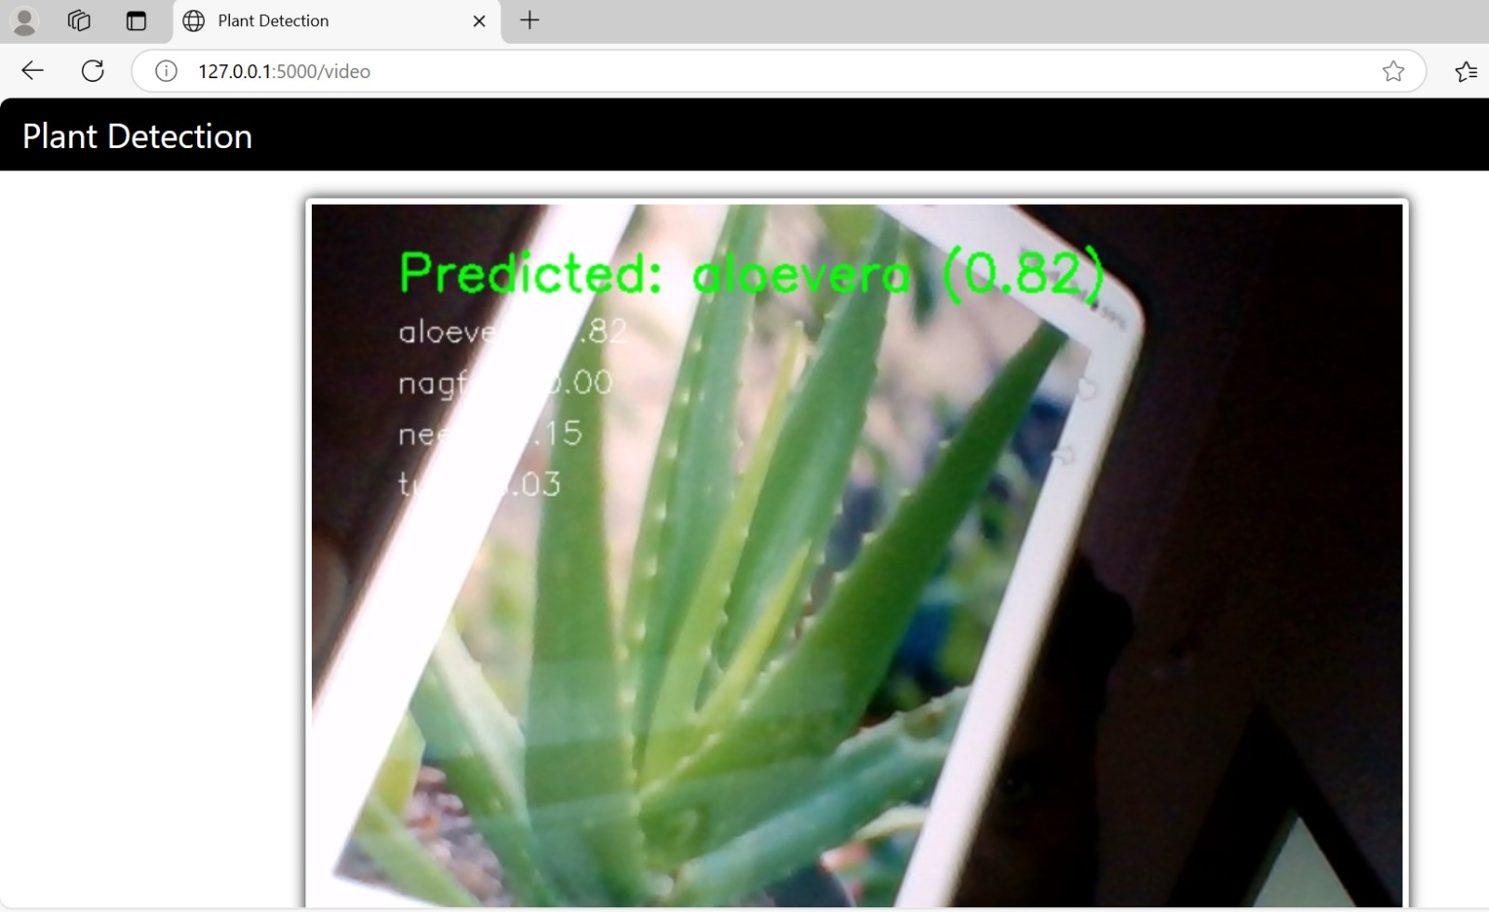



**Conclusion**

This project demonstrates the successful integration of **deep learning**, **computer vision**, and **web technologies** to create a **real-time medicinal plant species recognition system**. With a trained model based on **MobileNetV2**, the system provides accurate predictions and interactive feedback. The application has wide-reaching potential in fields like education, gardening, and conservation, offering a user-friendly tool for identifying plant species dynamically. Future improvements could involve expanding the number of plant species, enhancing the system’s robustness in varied environments, and exploring more advanced models for even better accuracy and performance.